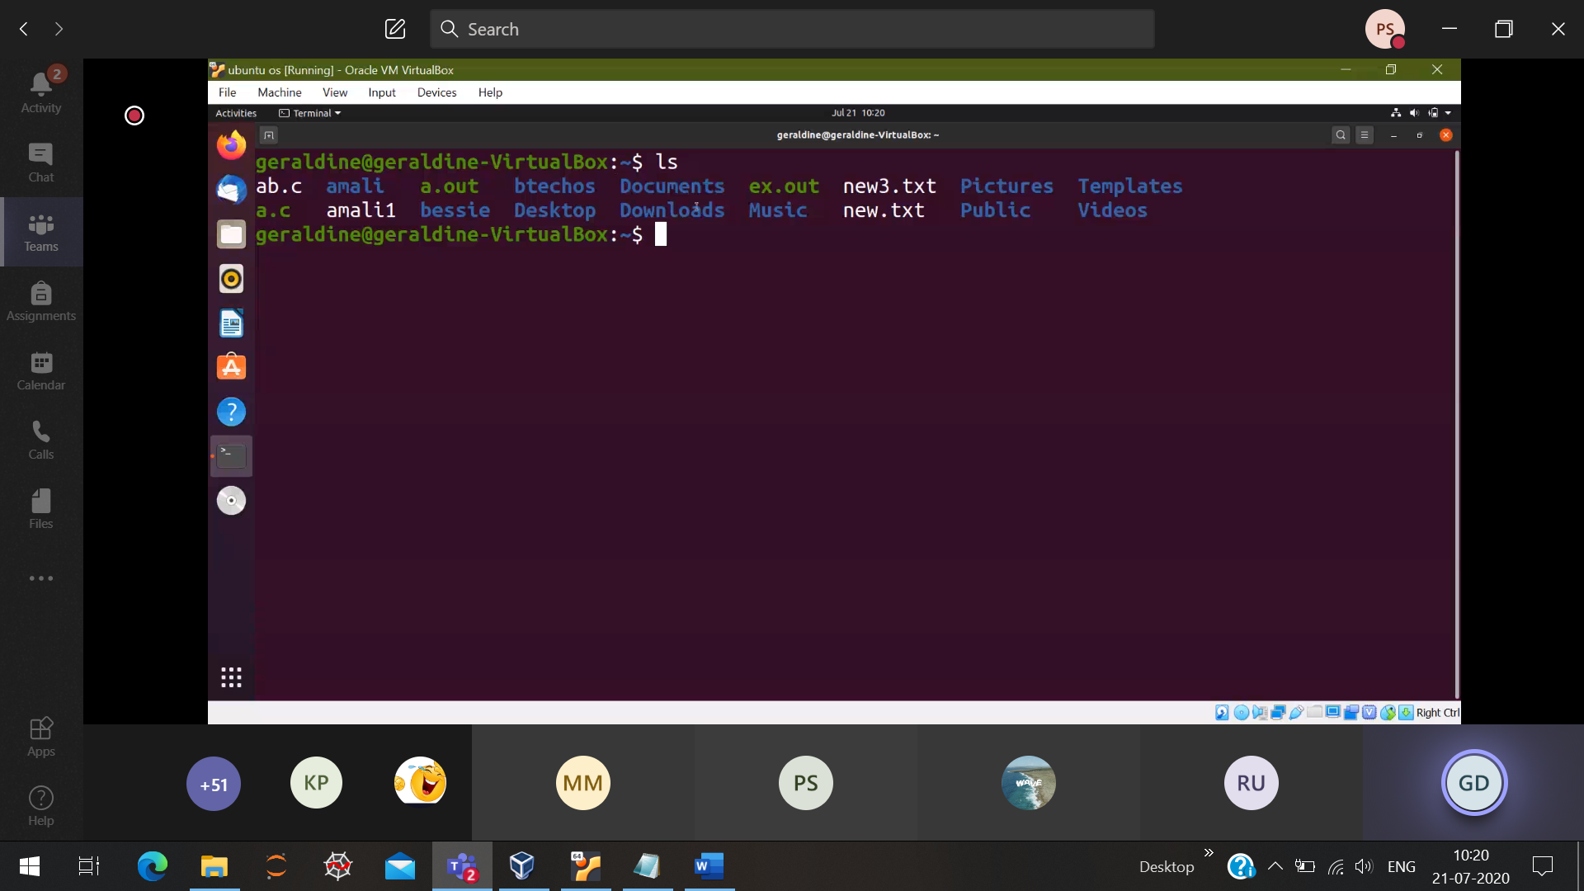

White color 🡪 Individual files

Blue color 🡪 Folder

Green color 🡪 executable files

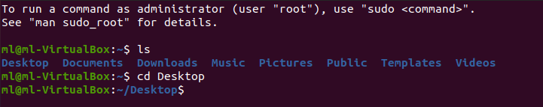

cd “Directory name” 🡪 Now I am Desktop directory

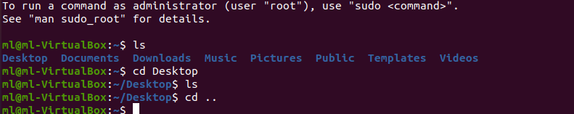

cd .. 🡪 Go back to the previous directory



history

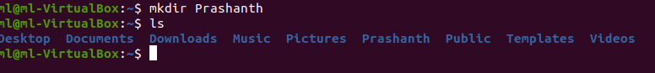

mkdir “folder_name” 🡪 Creates a new folder

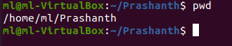

Present working directory from home

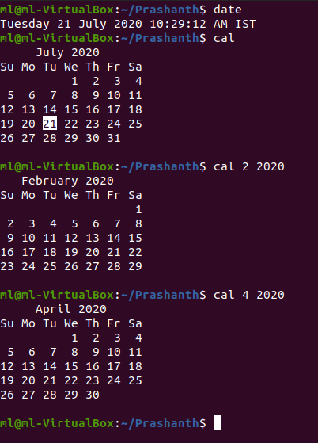

cal “month number” “year”

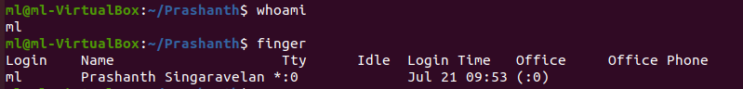

man “command name” . Quiting from the man and return to terminal : q

man ls 🡪 complete info about ls



vi “file_name”.extension

esc: wq 🡪 write and save

esc:q 🡪 only save

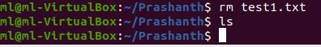

Deletes the file, and then type ls there will be no files

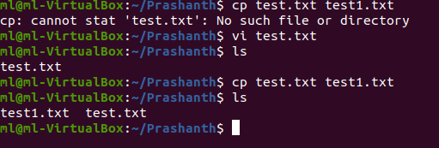

Copy 🡪 cp source_file destination file

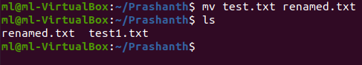

Rename 🡪 mv old_file new_file_name

Displays the content of the file in the terminal itself 🡪 cat “file_name”

Display s head “file_name”

tail “file name”

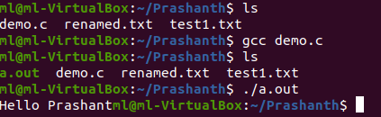

gcc “file_name.c” 🡪 Compile the current file

a.out (green color) which is the executable file. Then run that executable file to get the output

./a.out 🡪 To get the output

Default previlage for all the users

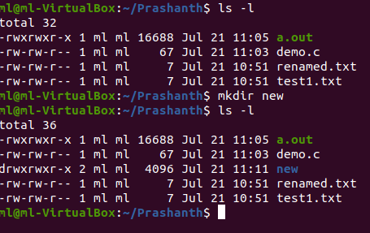

chmod 775 text.txt

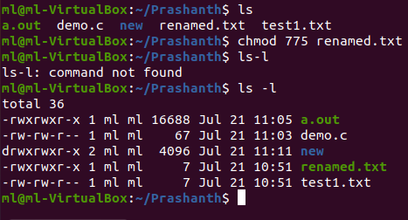

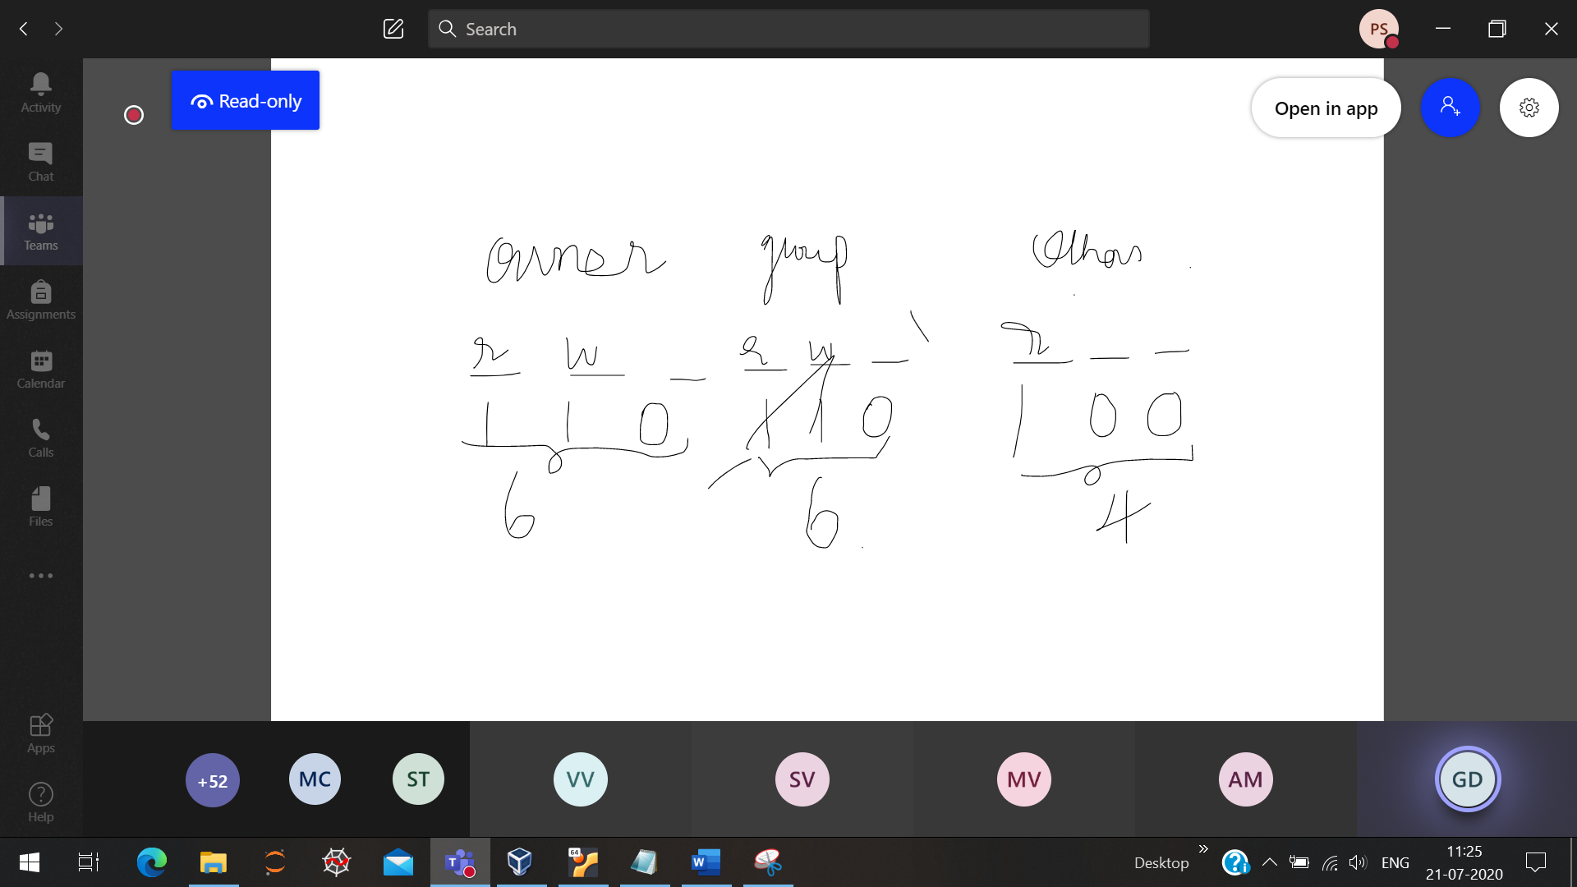

7 7 5

1 1 1 1 1 1 1 0 1

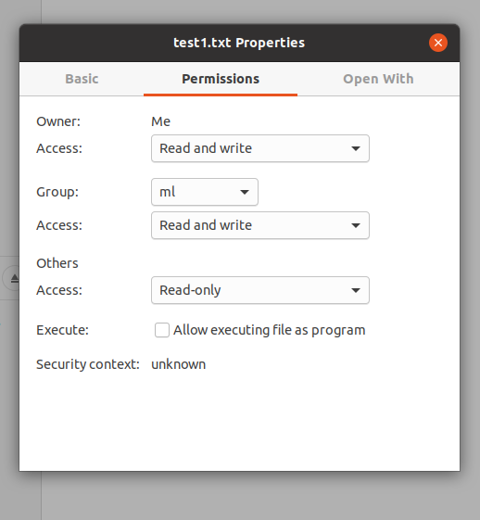

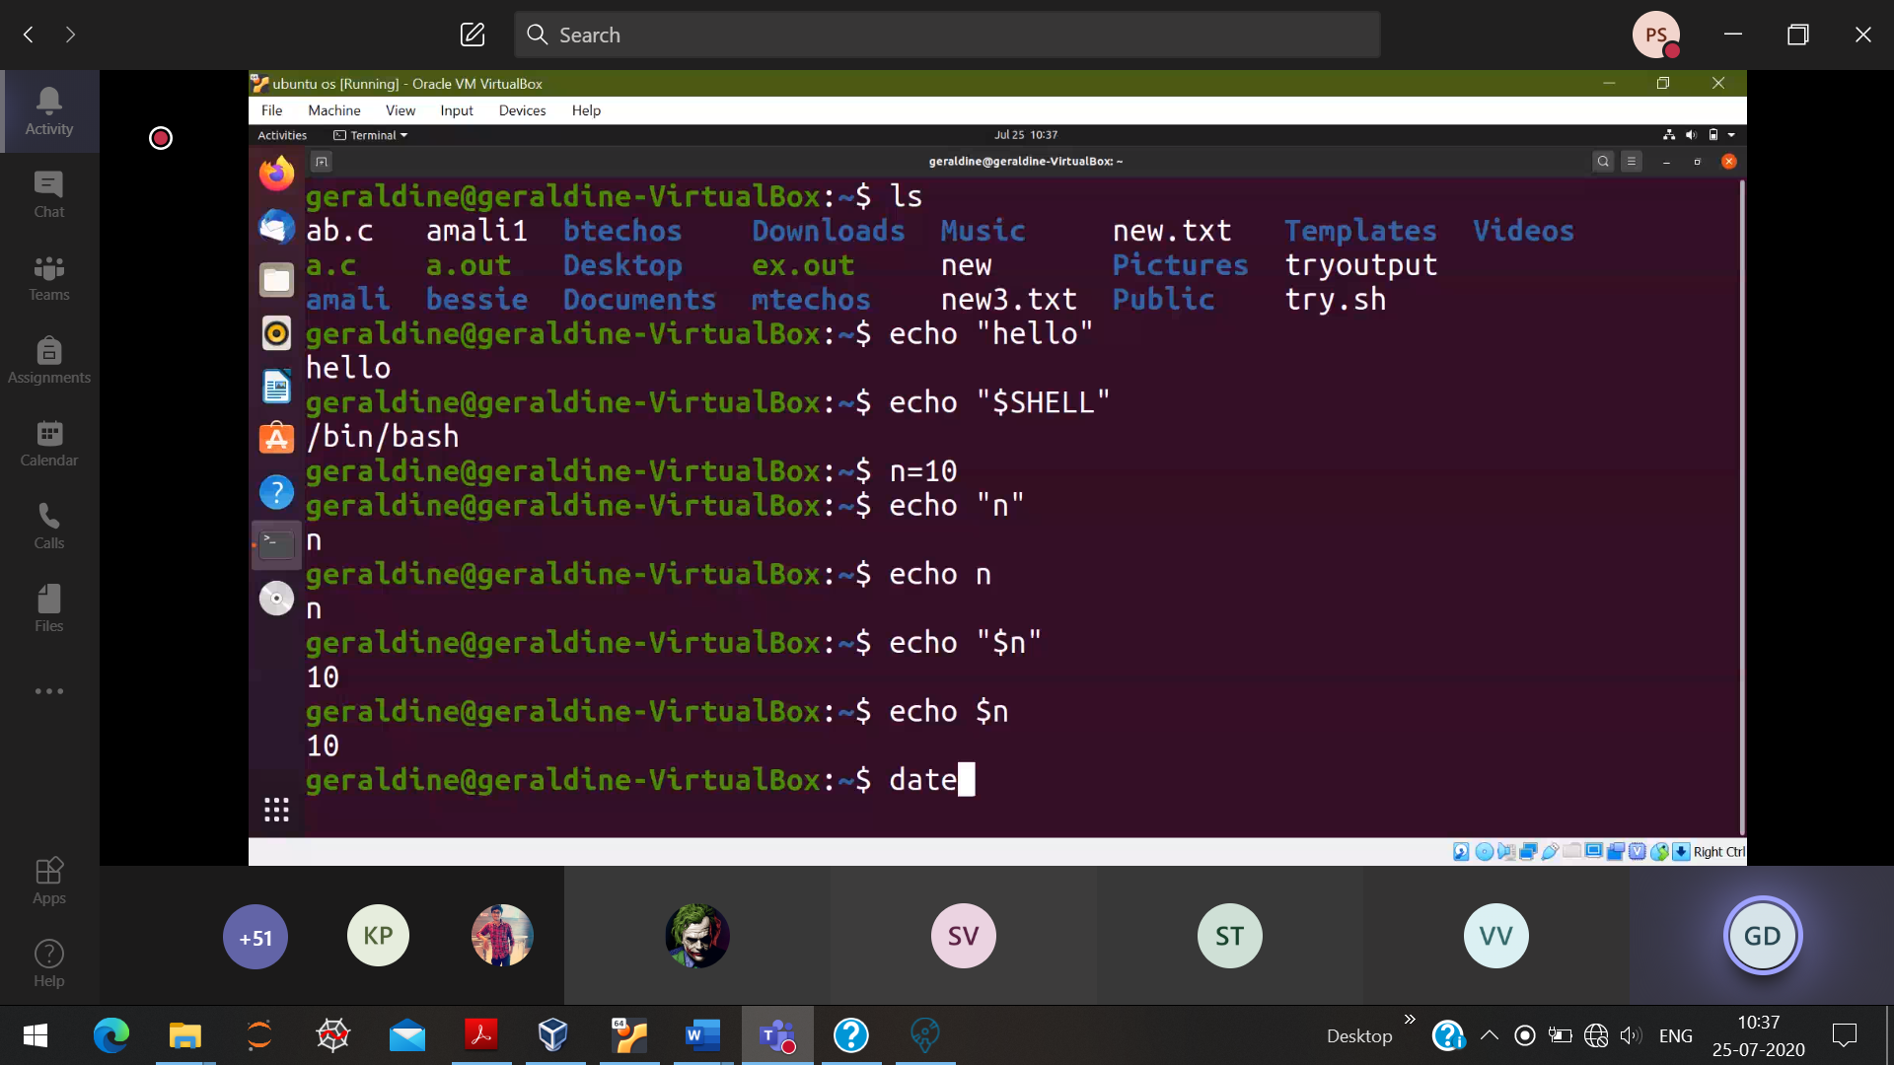

“$n” 🡪 value of n

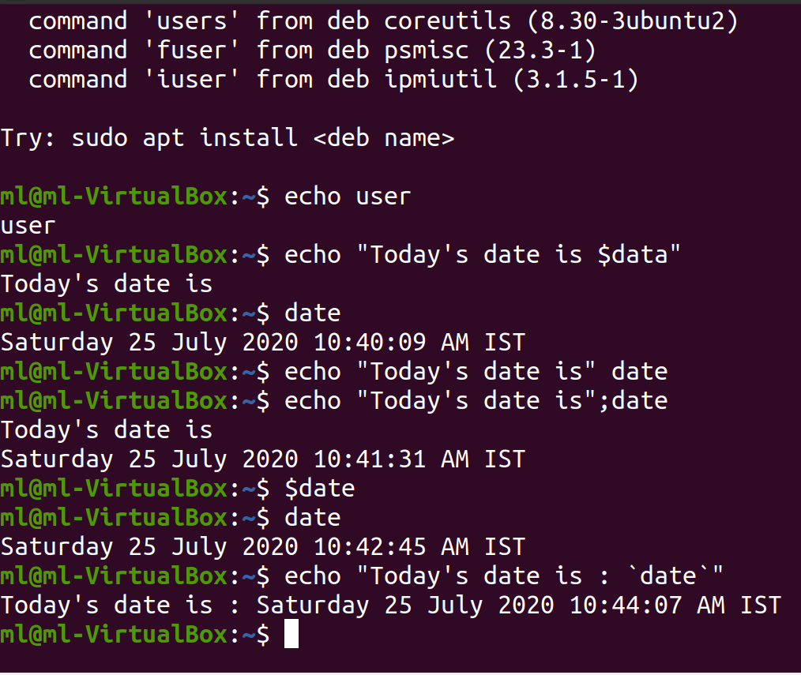

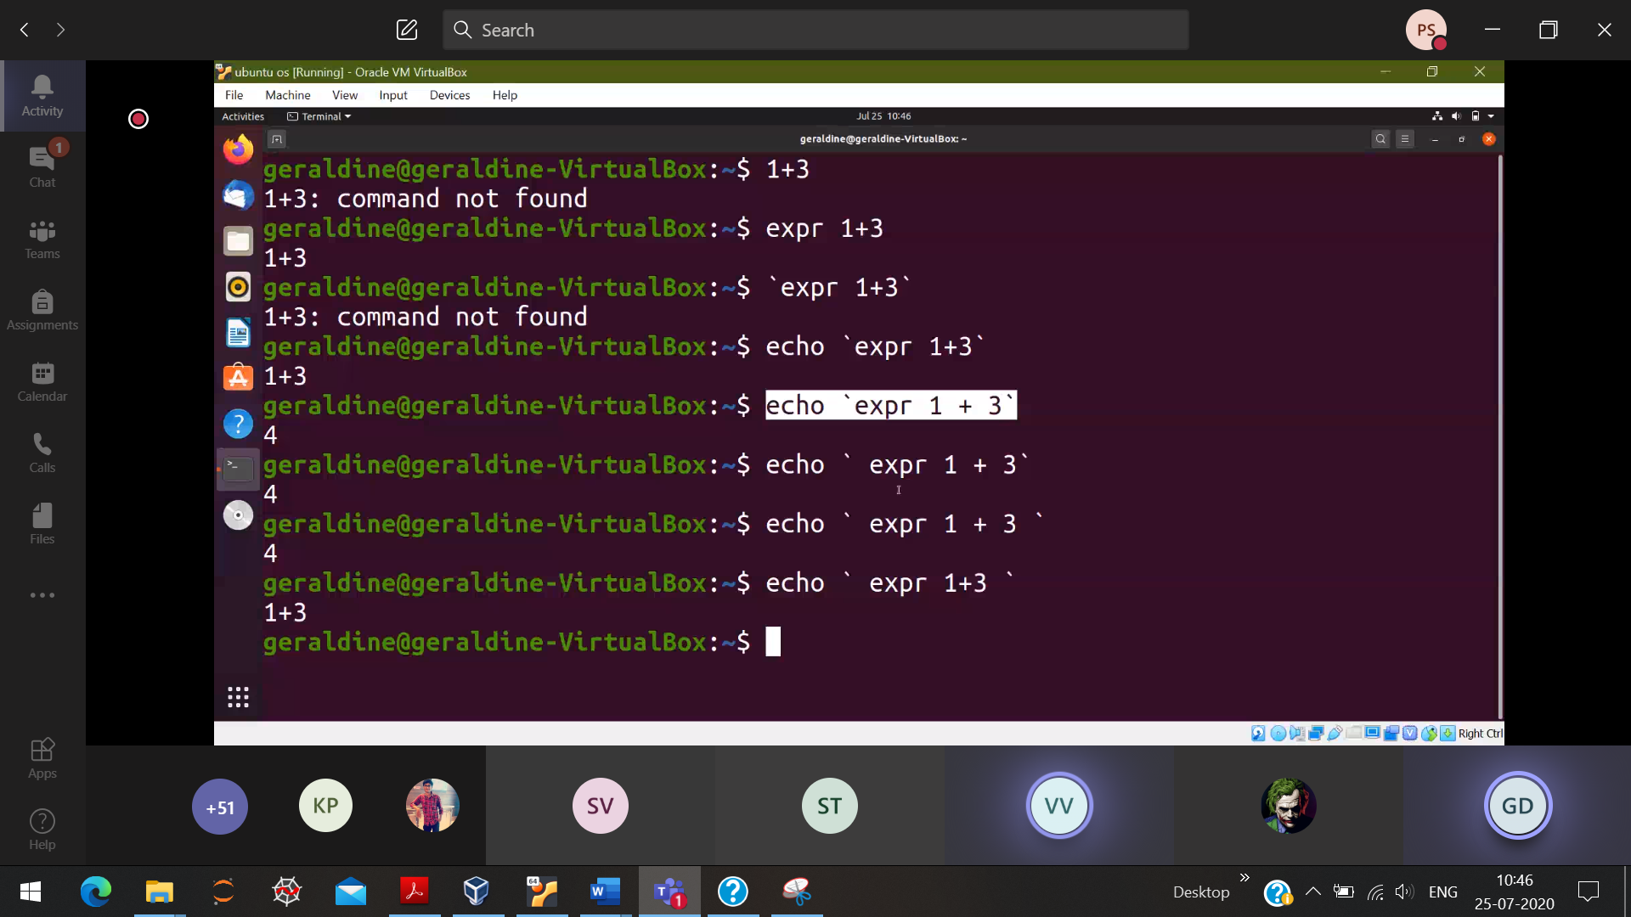

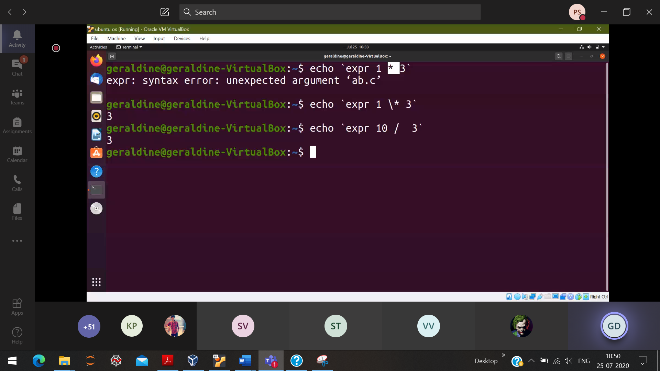

*has a special meaning, so it doesn’t mean as product

Echo 🡪 printf

Read 🡪 scanf

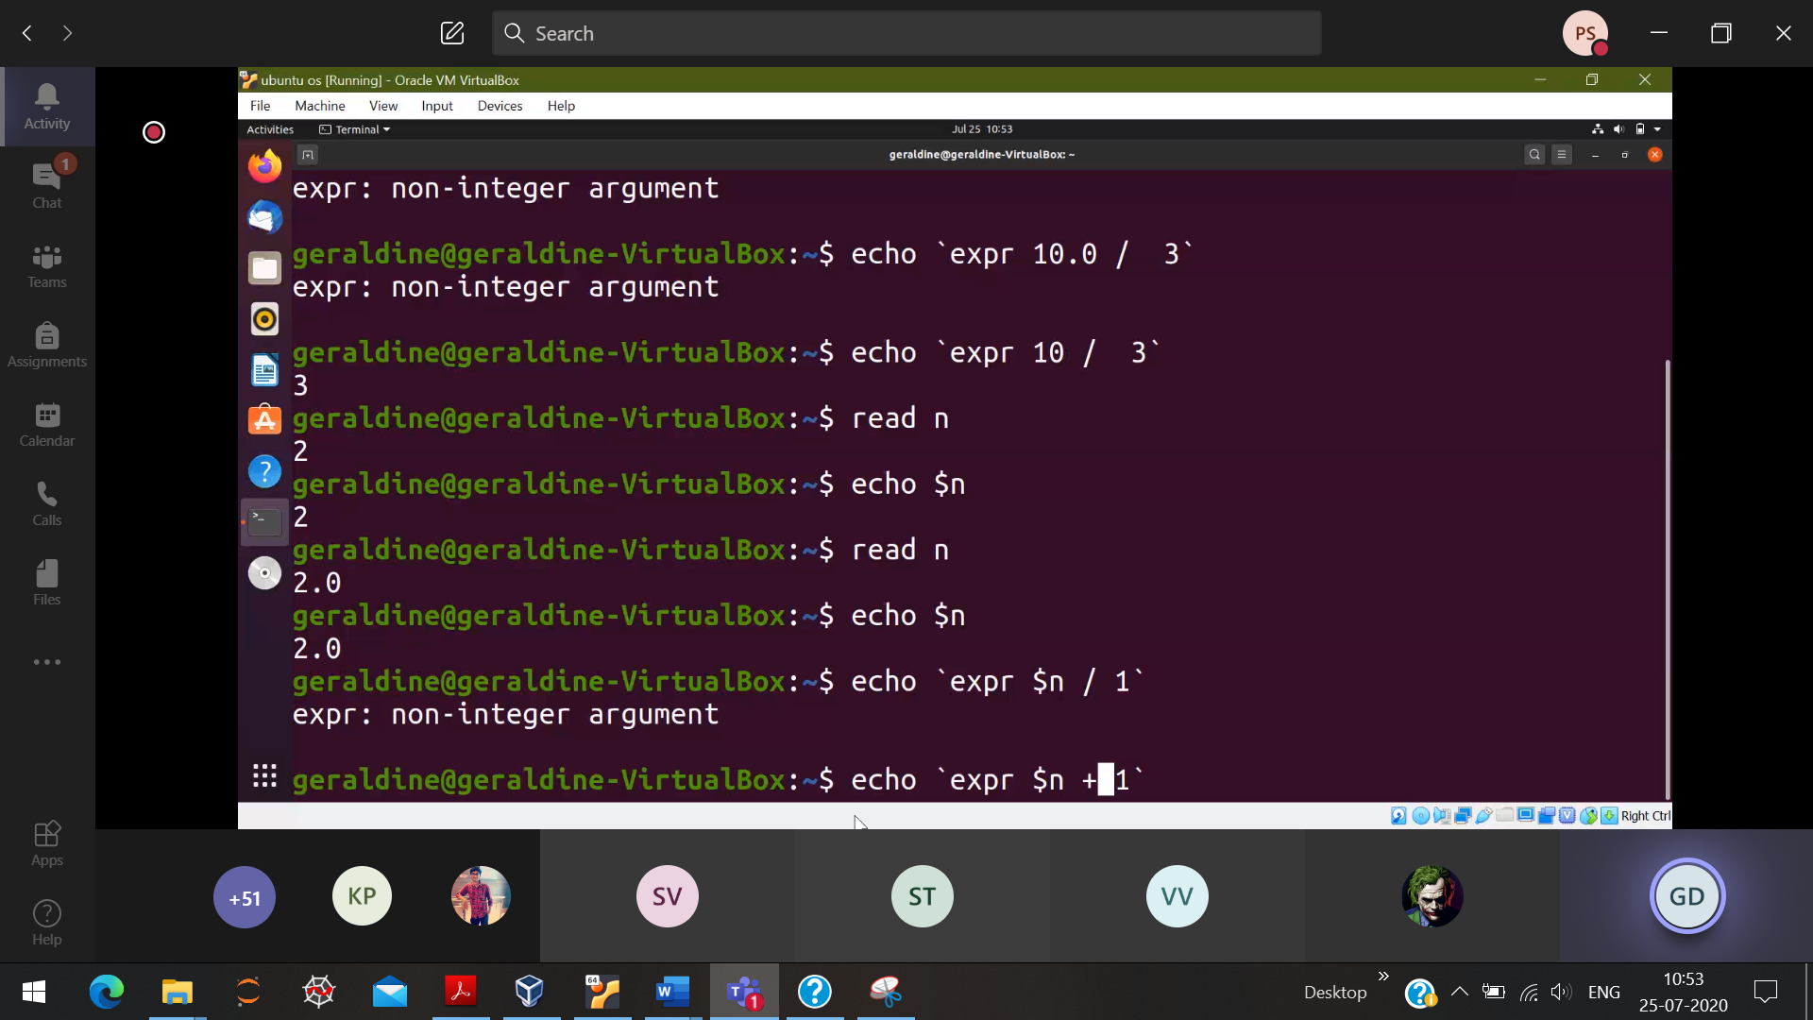

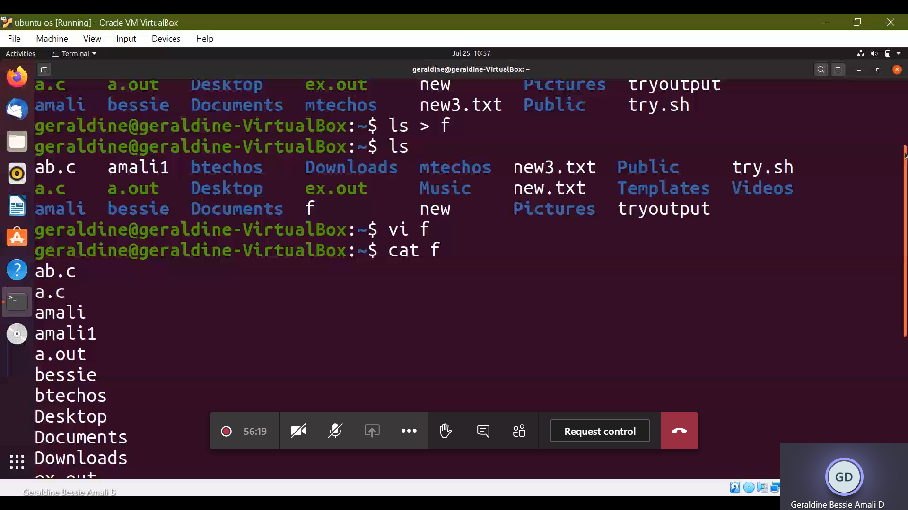

Writing the contents of ls into a new file and displaying it

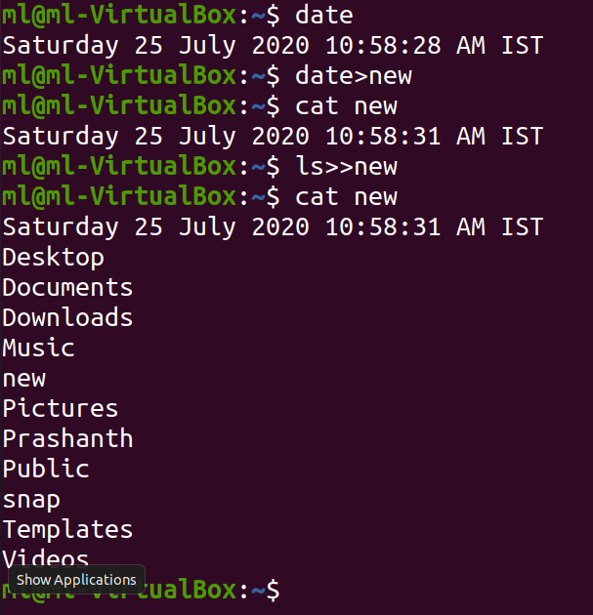

Simply overwriting /appending the contents into a file

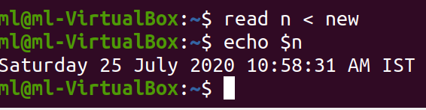

Reading from a file

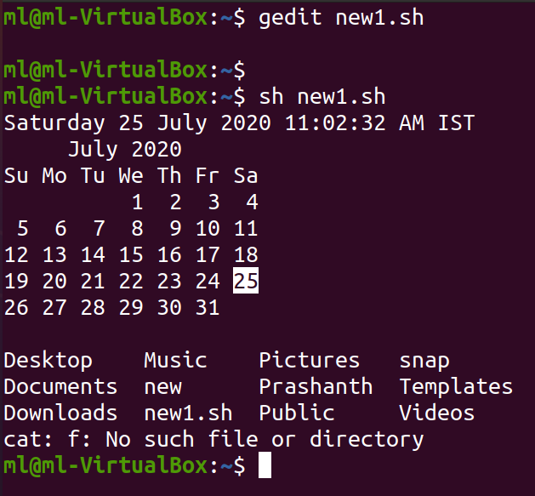

Create a new file, write the content . then display that file contents

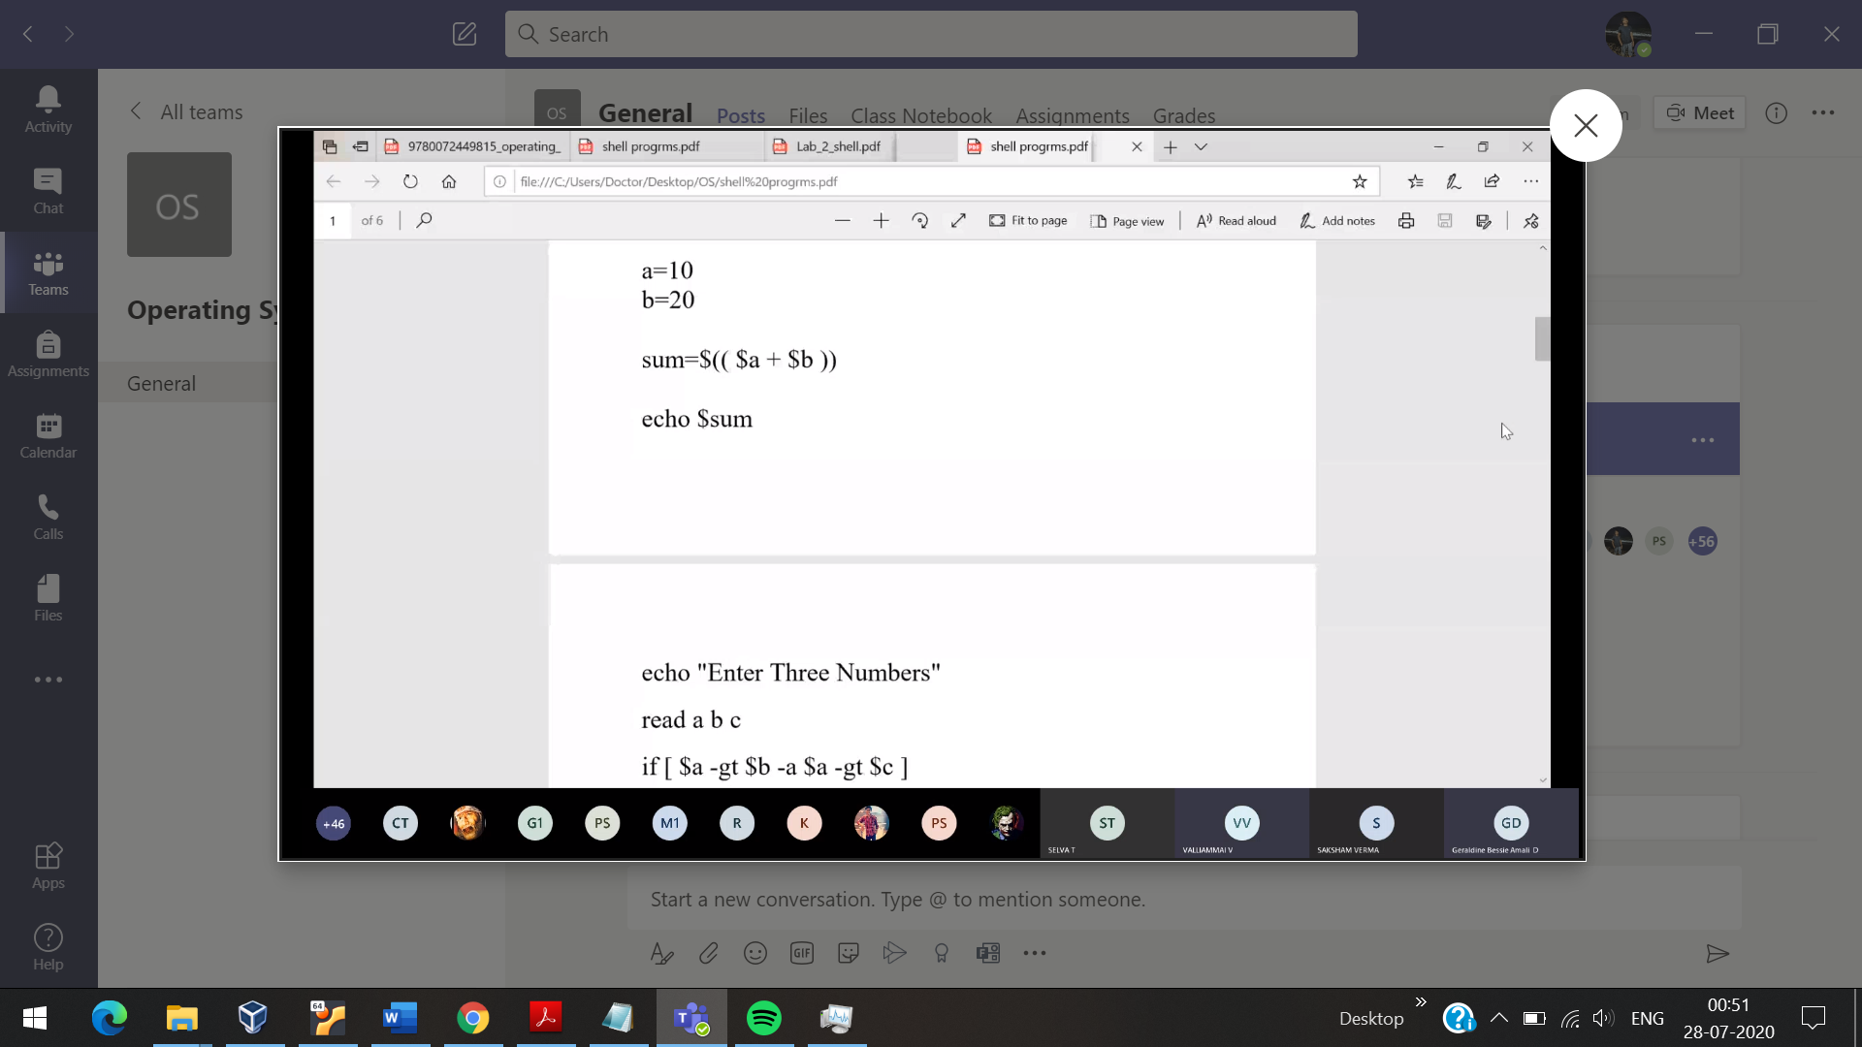

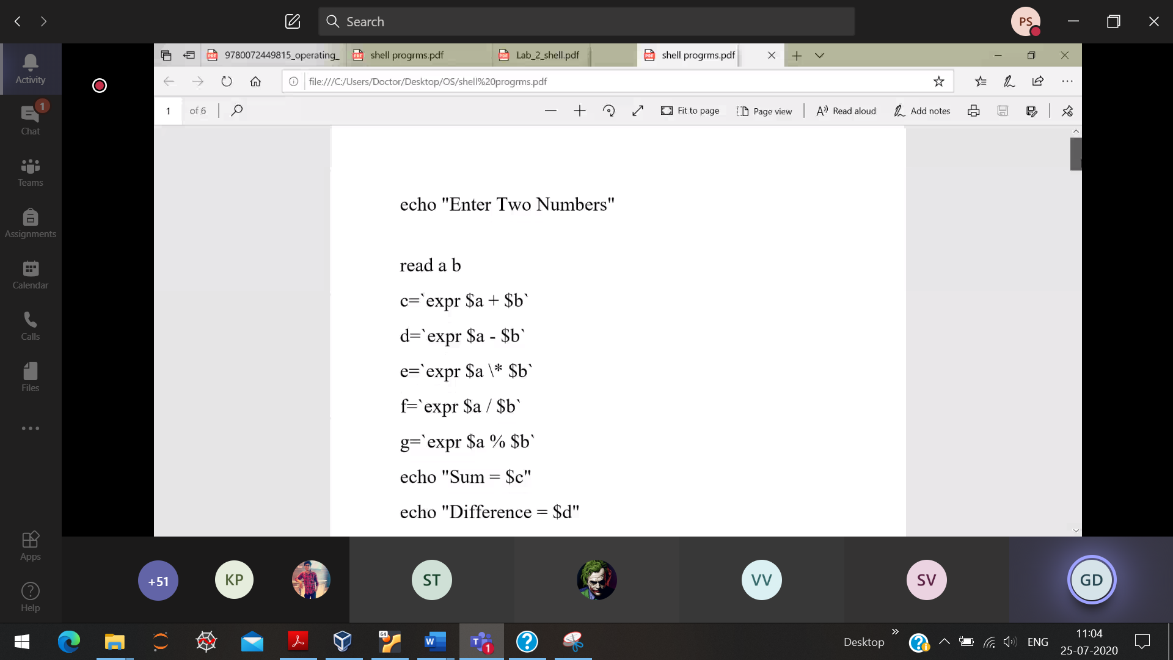

If else

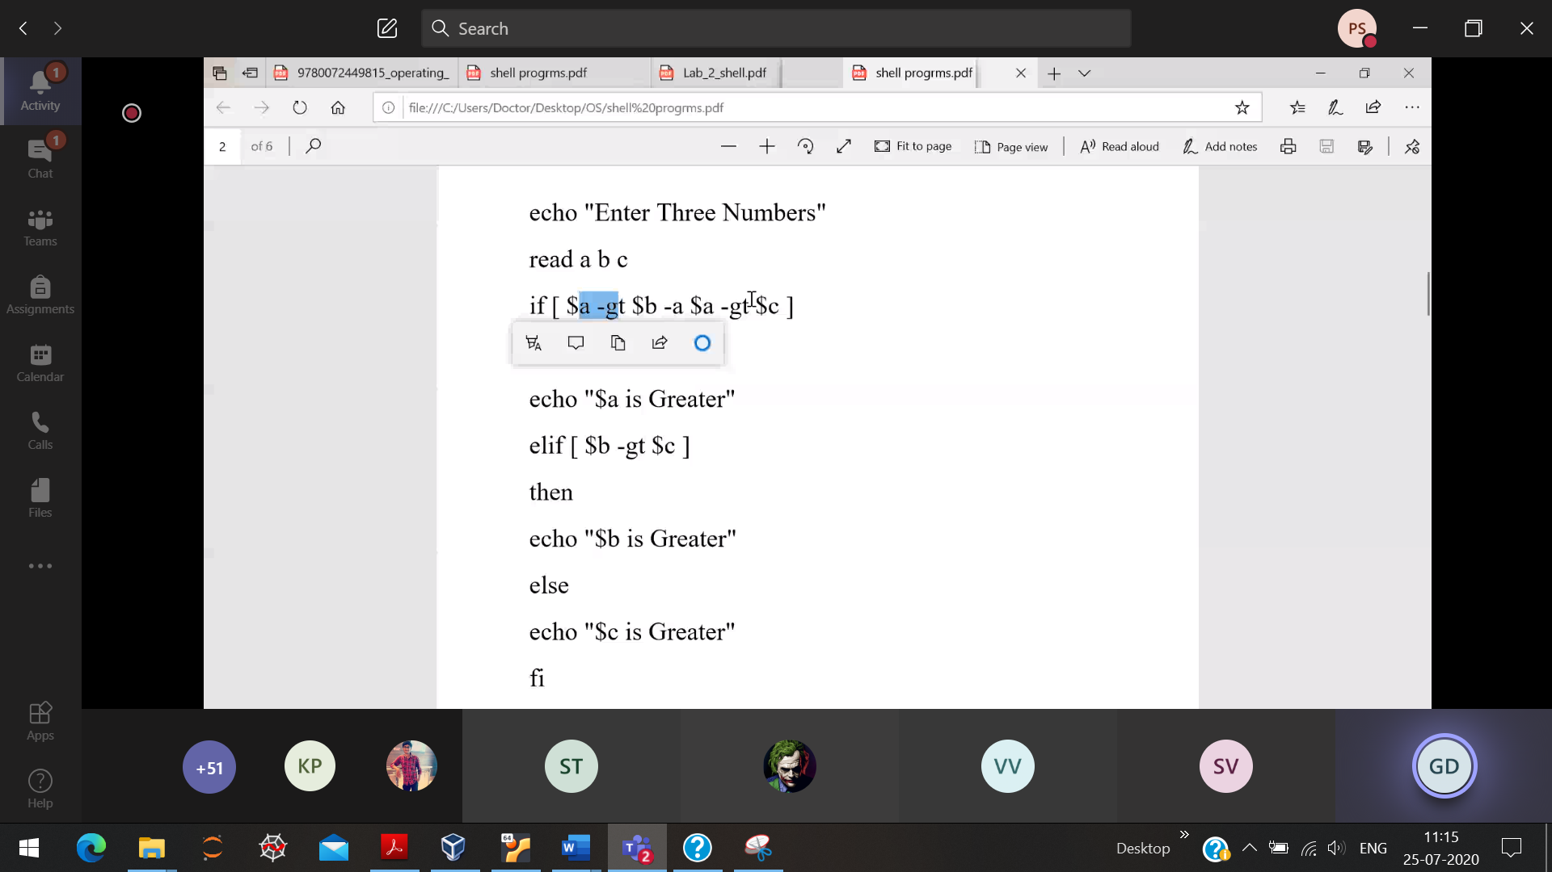

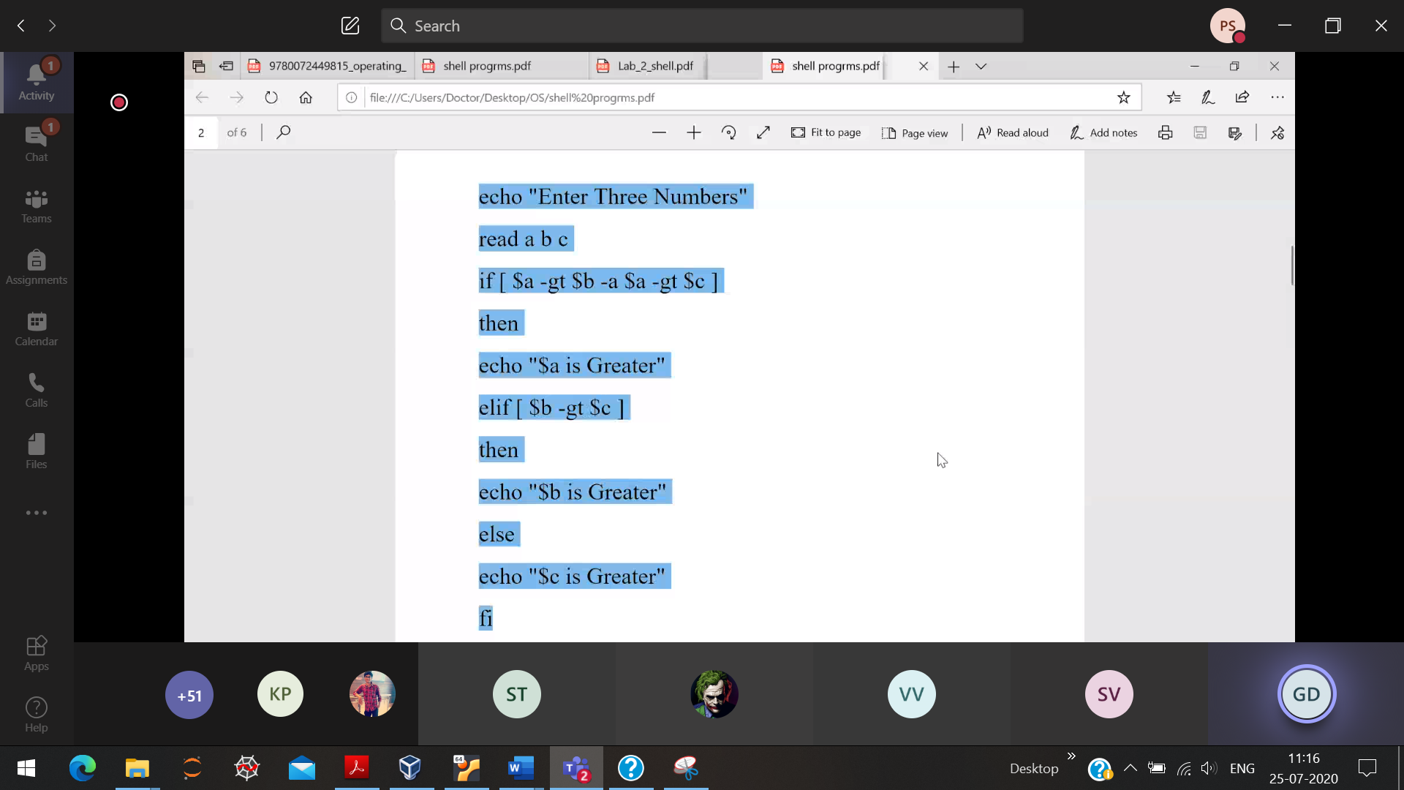

28/7/20

Different if statements

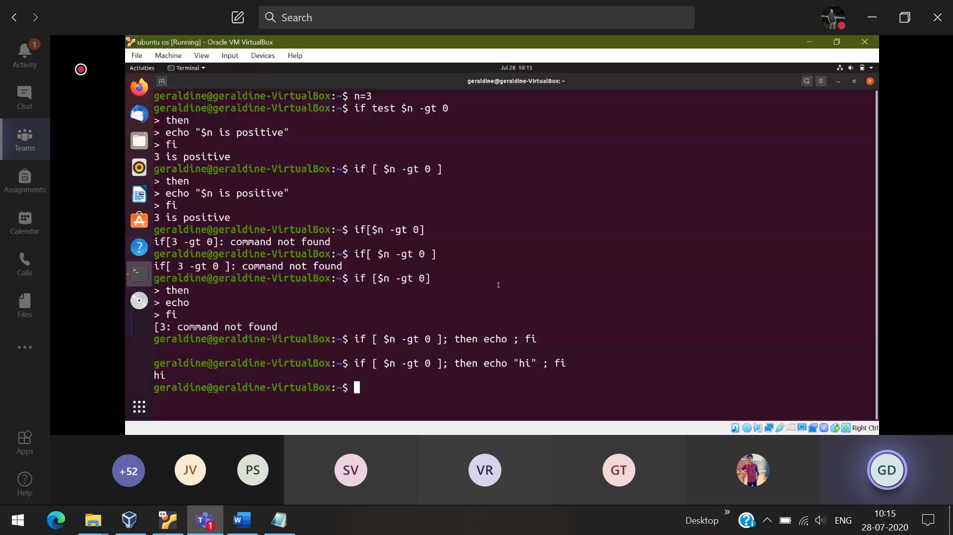

Nested if else

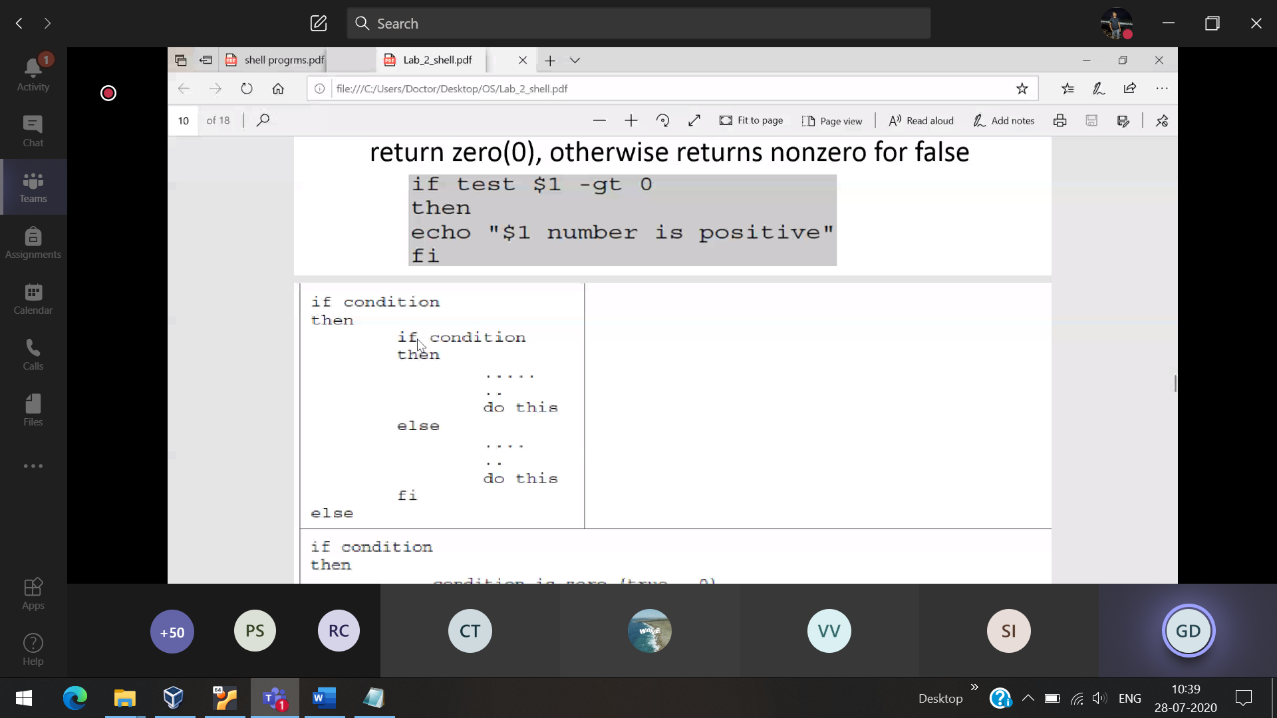

While loop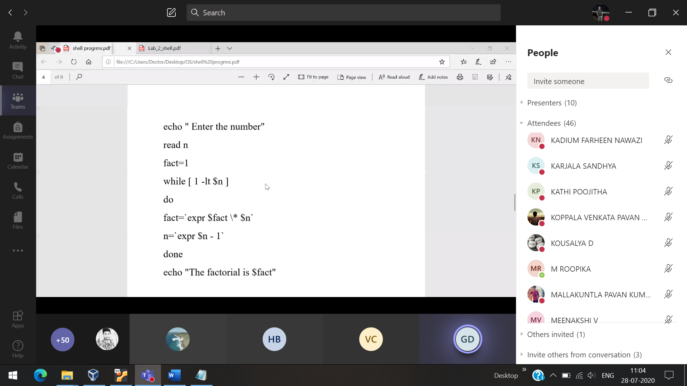

For loop

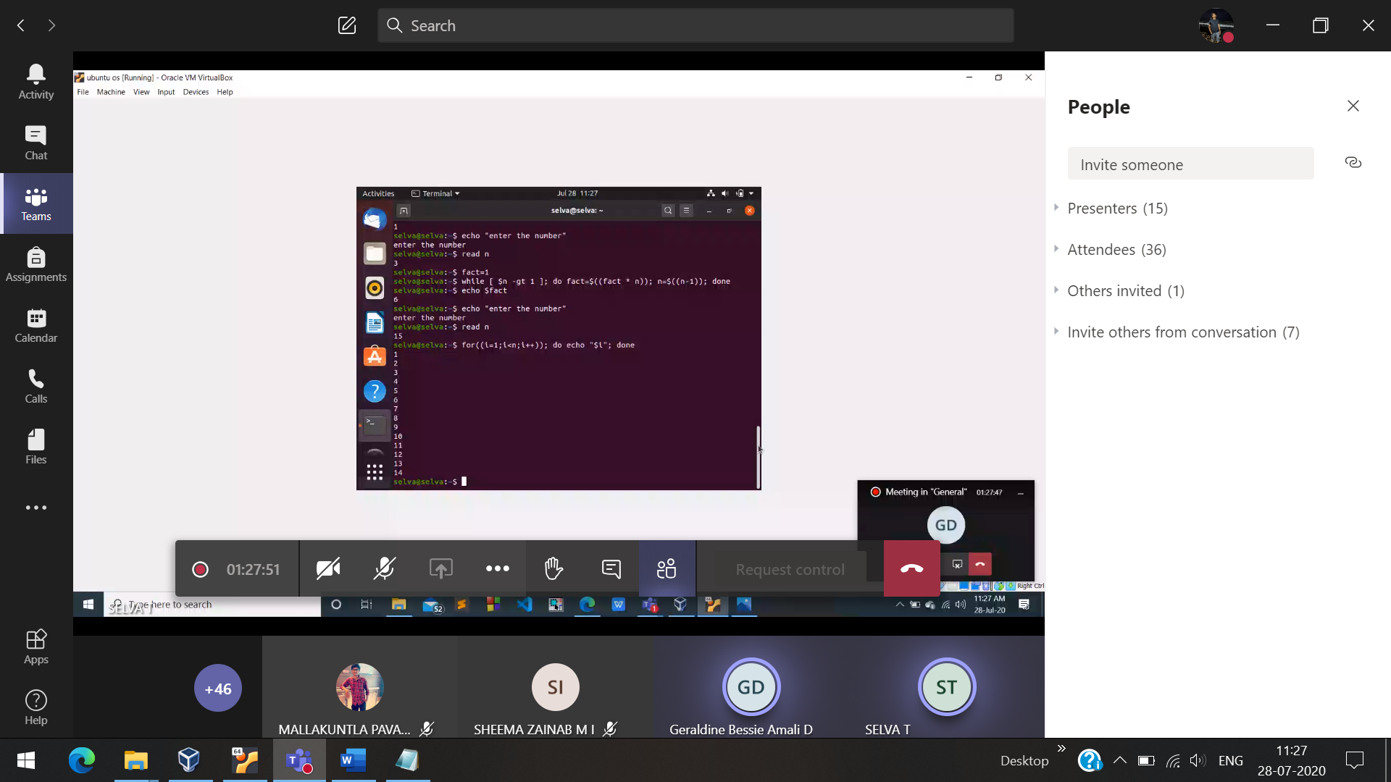

New way of adding

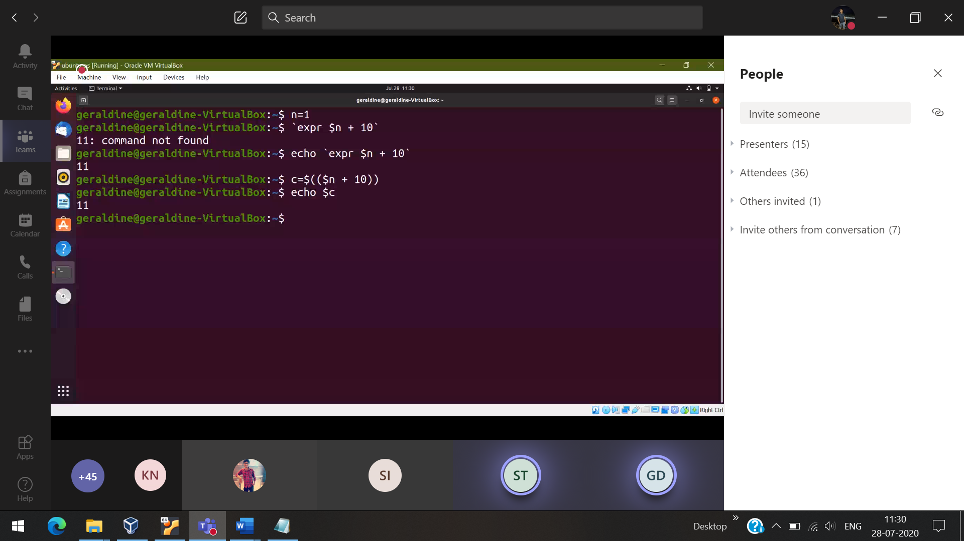

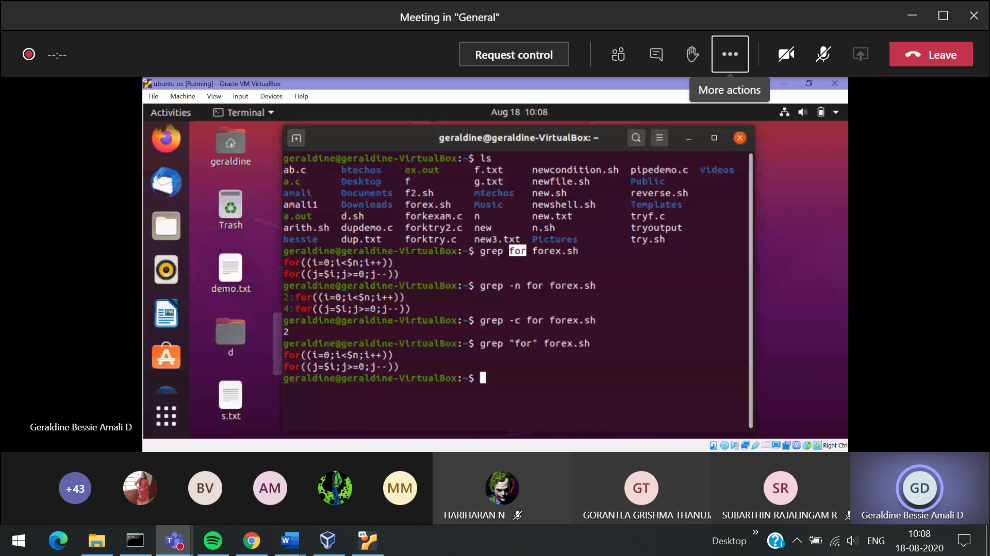

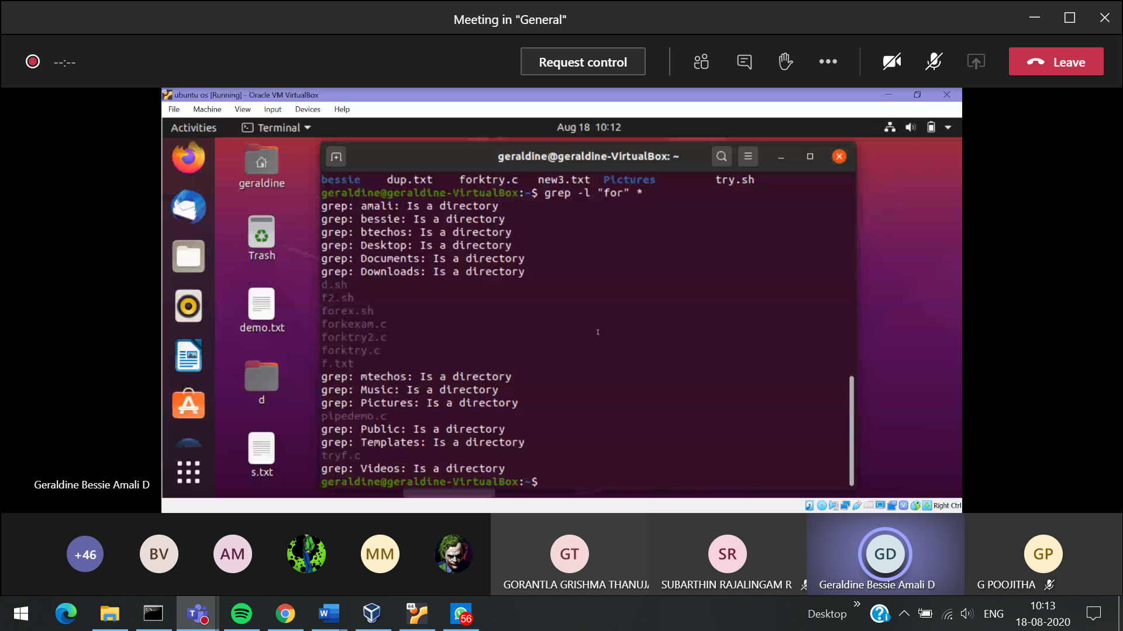

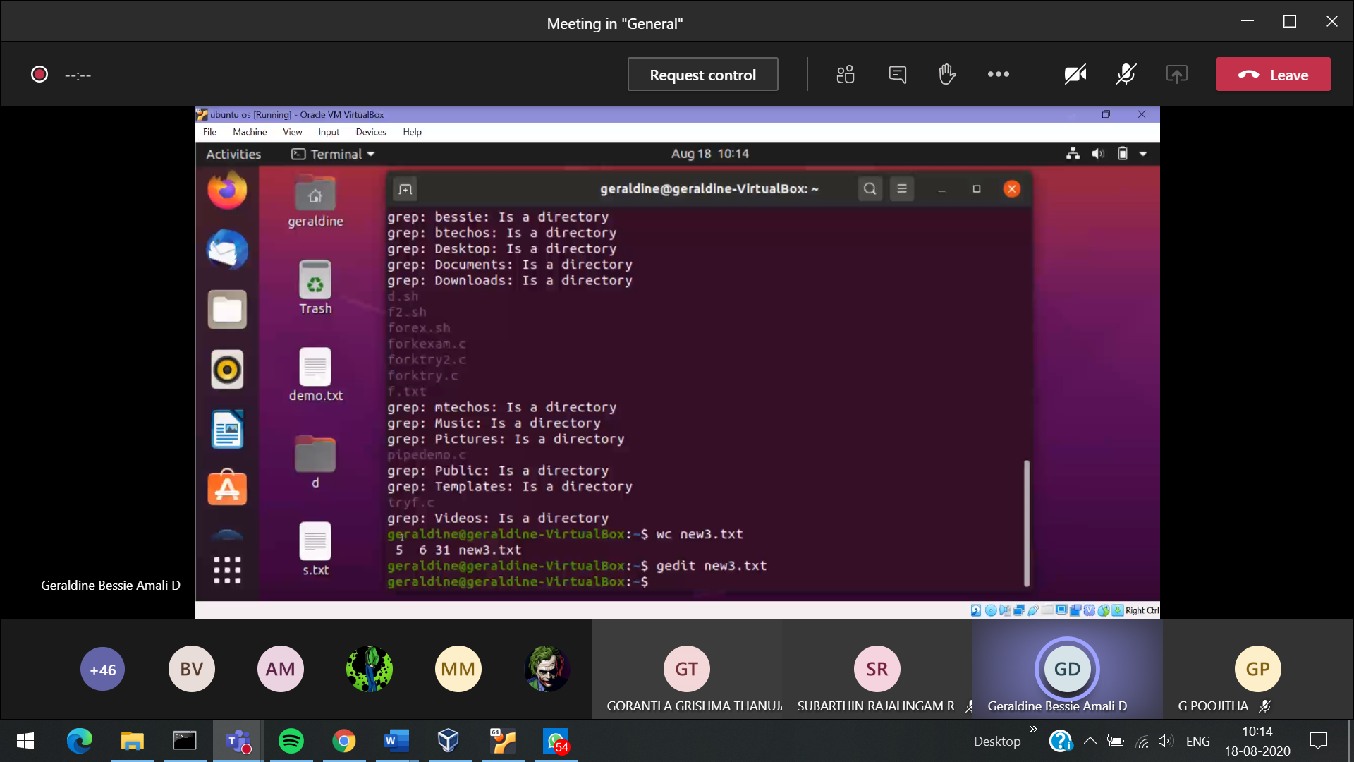



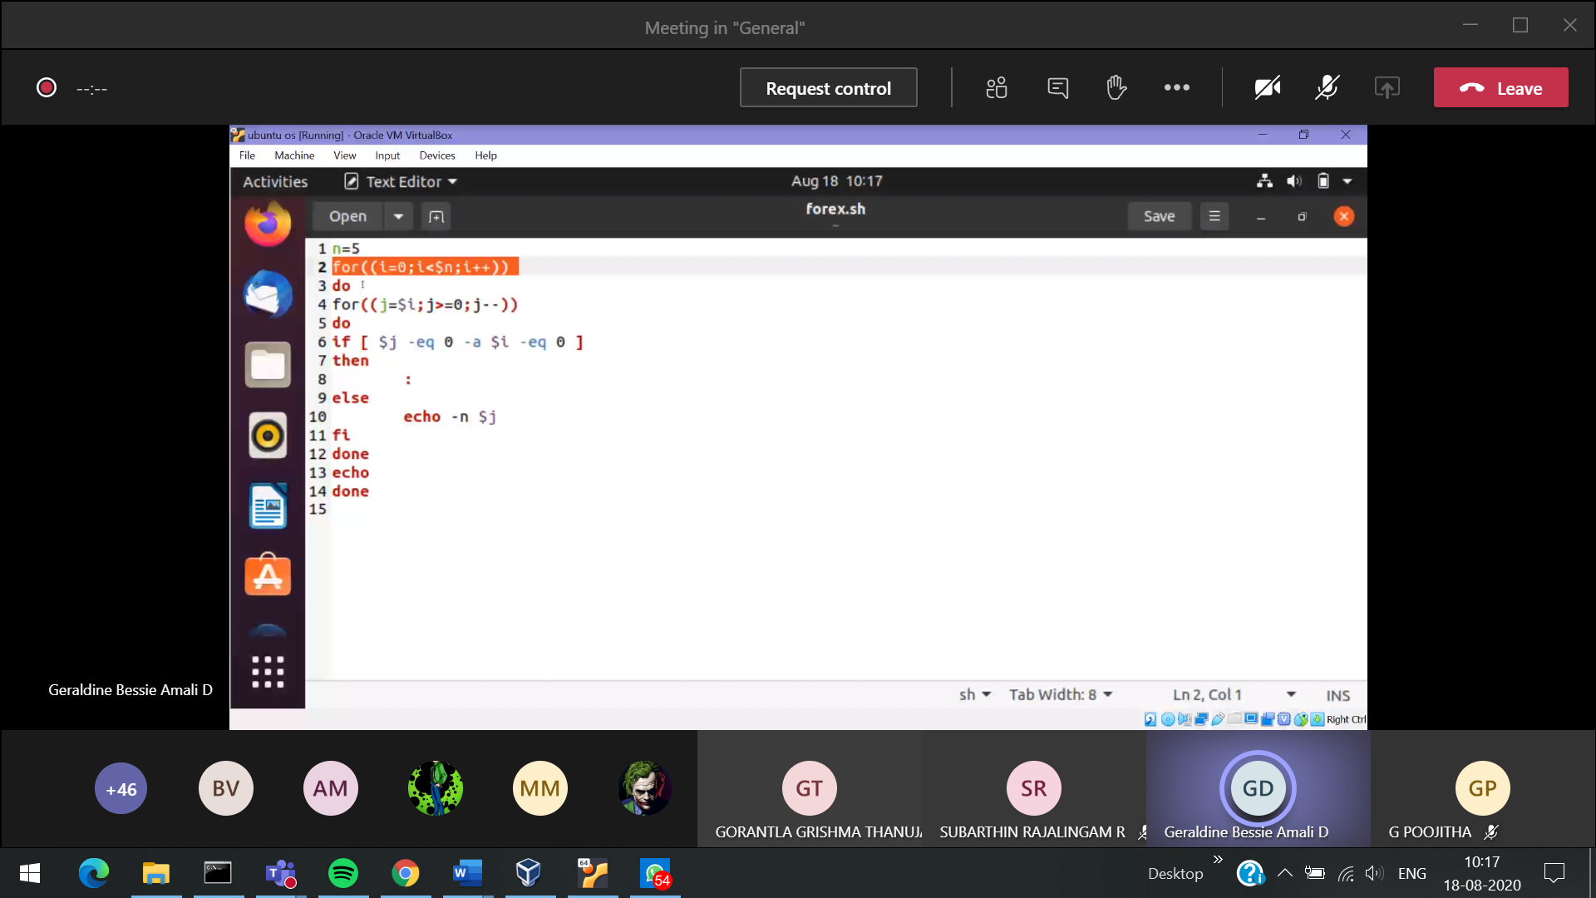

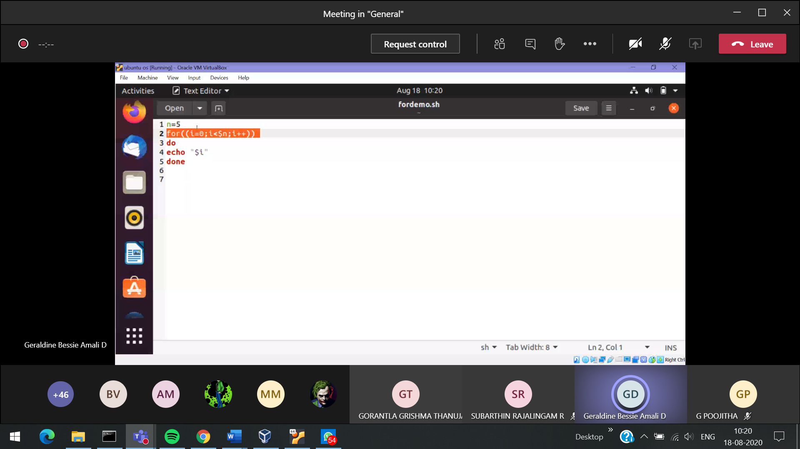

To tun 🡪 bash filename.sh

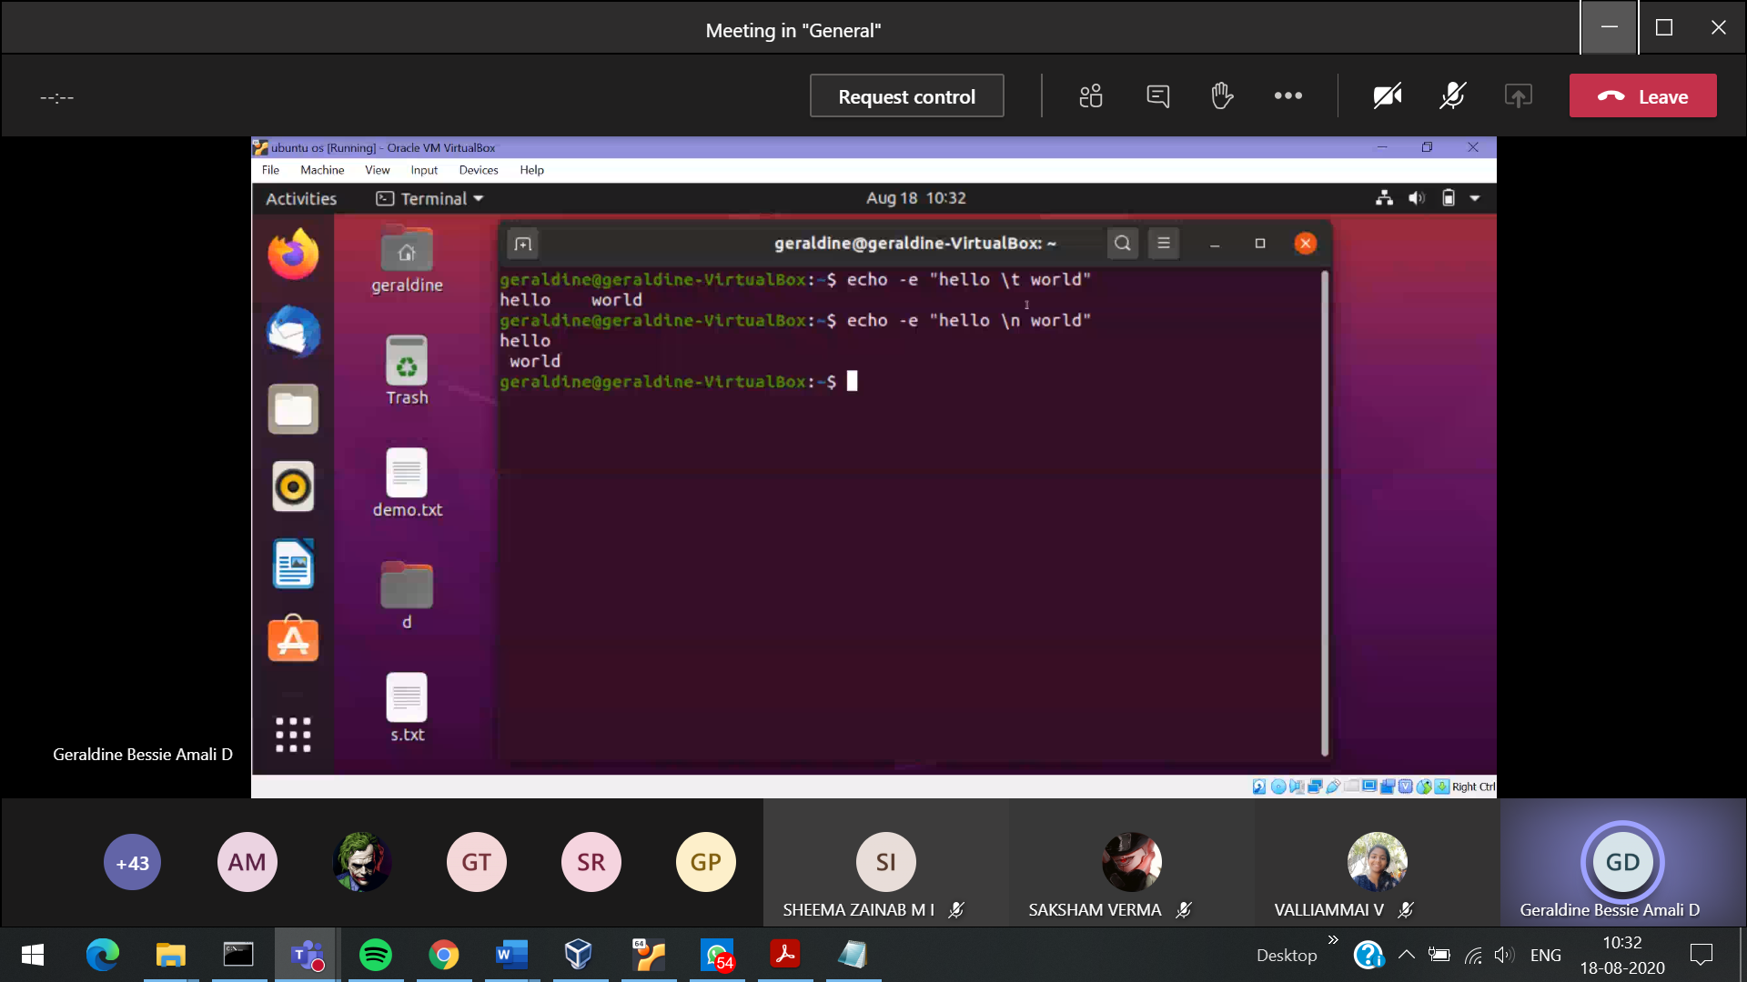

Assignment-1

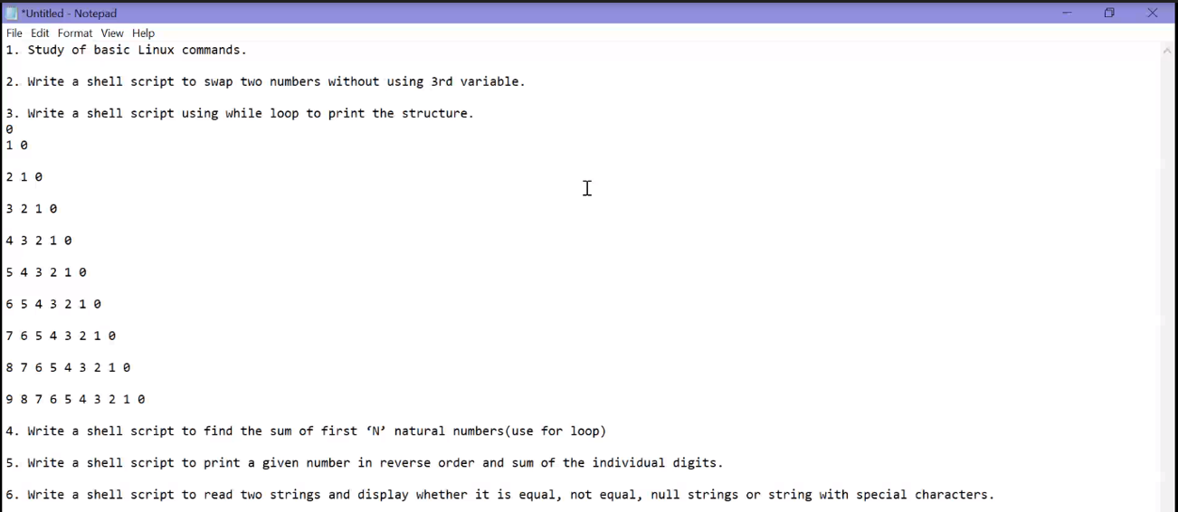

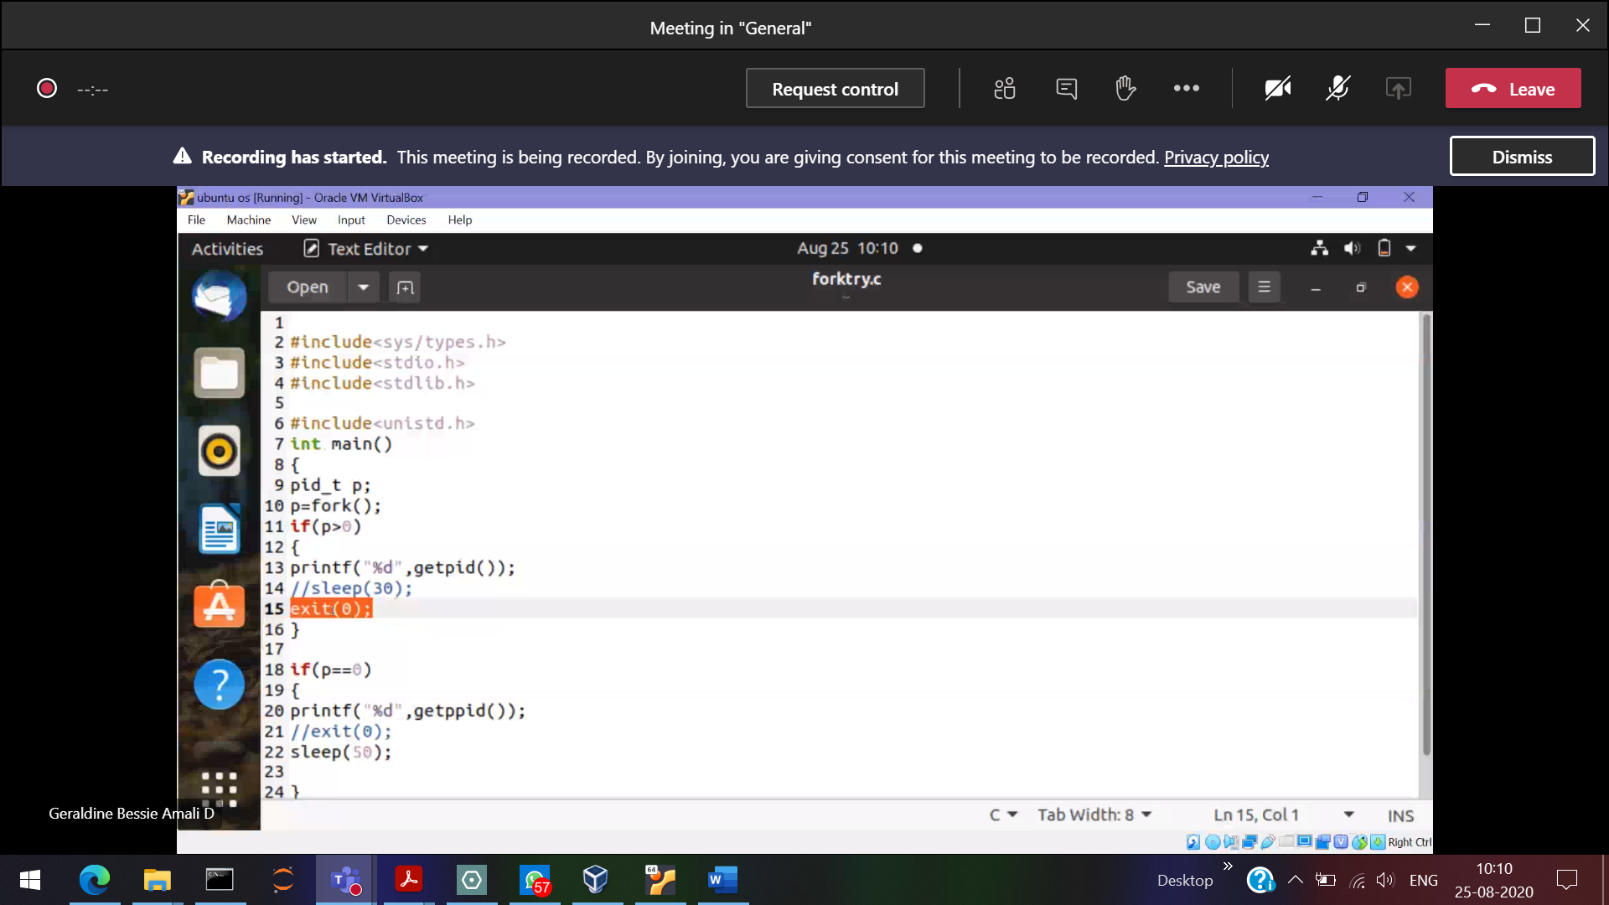

Zombie process 🡪 Parent sleeping that time child exits()

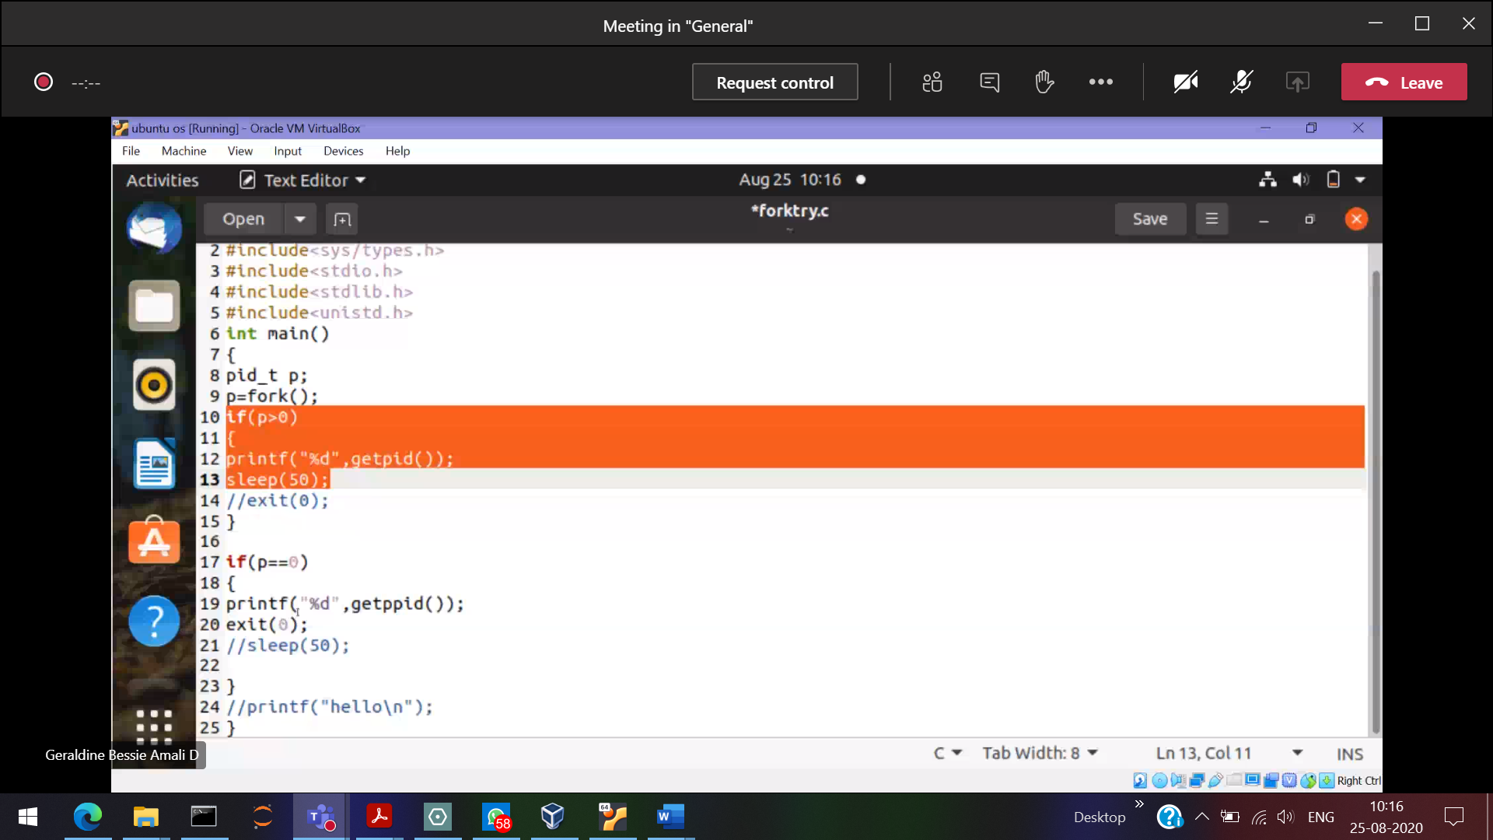

5386 Parent is died and the adopted parent is 926

To kill a process 🡪 kill<process_id>

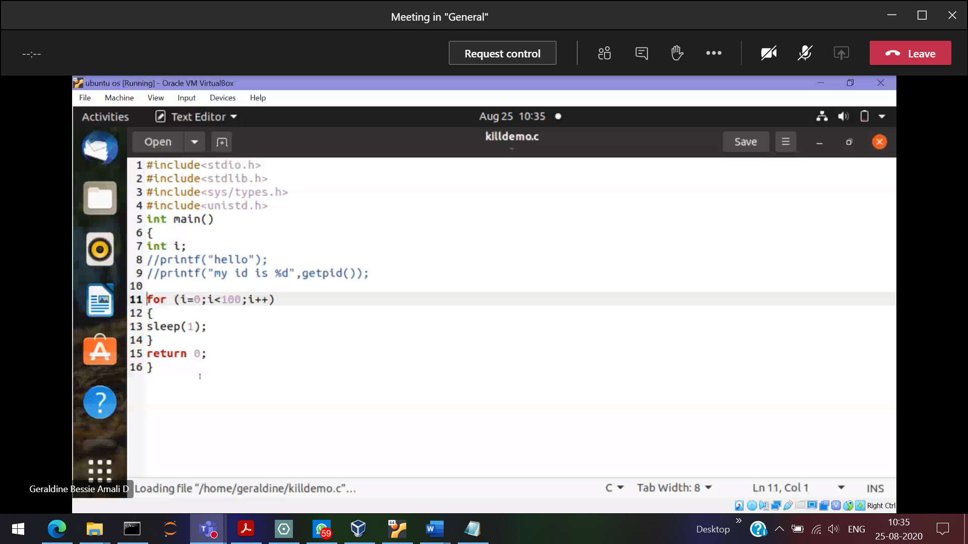

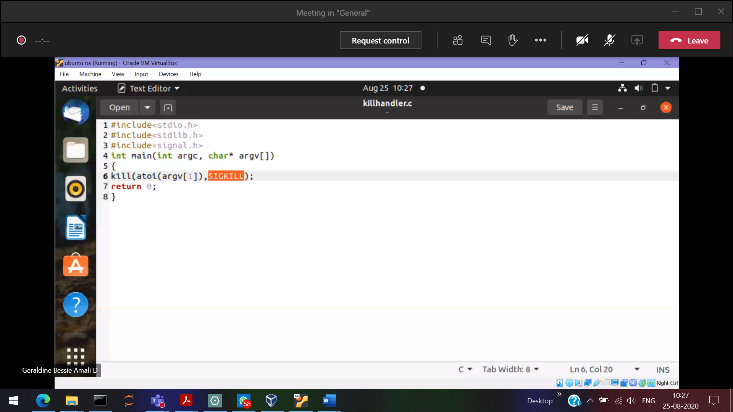

Orphan process 🡪 Child sleeps , Parent exits()

